Human Computer Interaction (HCI)

Assignment No 1

**Name: Saad Ahmed**

**Sid: 62499**

**Cid: 104498**

**Submitted To: Afshan Saad**

***BAD DESIGN***

**Example# 1**

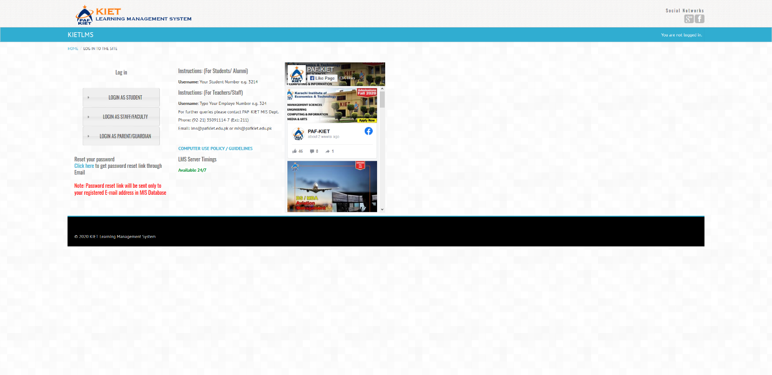

**Reasons:**

1. Not good design
2. Not responsive
3. **The loading time is very bad**
4. **Lot’s of features but not work properly**
5. **Hard to communicate**
6. **Complex design**
7. **No proper implementation with server**
8. UI design not user friendly
9. Unnecessary complexity
10. Lack of engagement

**Example# 2**

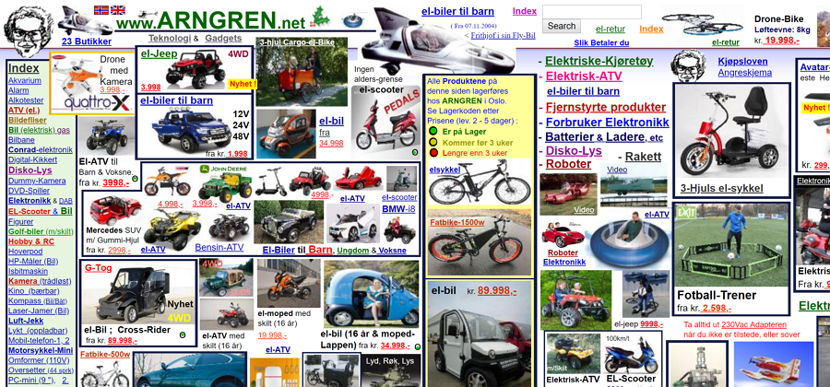

**Reasons:**

1. The biggest problem is that the site doesn't use a grid.
2. Unbelievable navigational structure.
3. Poor typography makes it unreadable.
4. Random use of colors.
5. Not clean layout
6. The design in not responsive
7. Poor use of animations/gifs
8. The content is not organized
9. Not user friendly
10. Lack of engagement

**Example# 3**

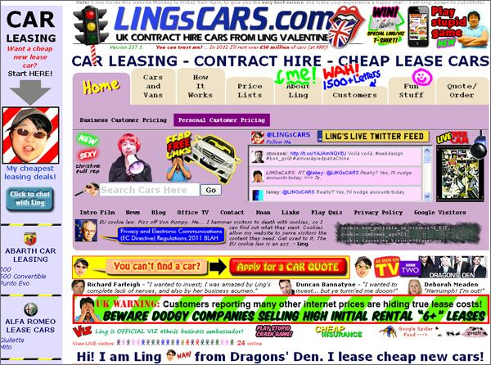

**Reasons:**

1. No user friendly
2. No proper use of grid system
3. Not responsive for other devices
4. Poor images quality
5. Improper/unorganized content
6. Improper uses of font size/style make it unreadable
7. Annoying design
8. Boring UI
9. Unnecessary complexity
10. Inconsistent style

***Good Design***

**Example# 1**

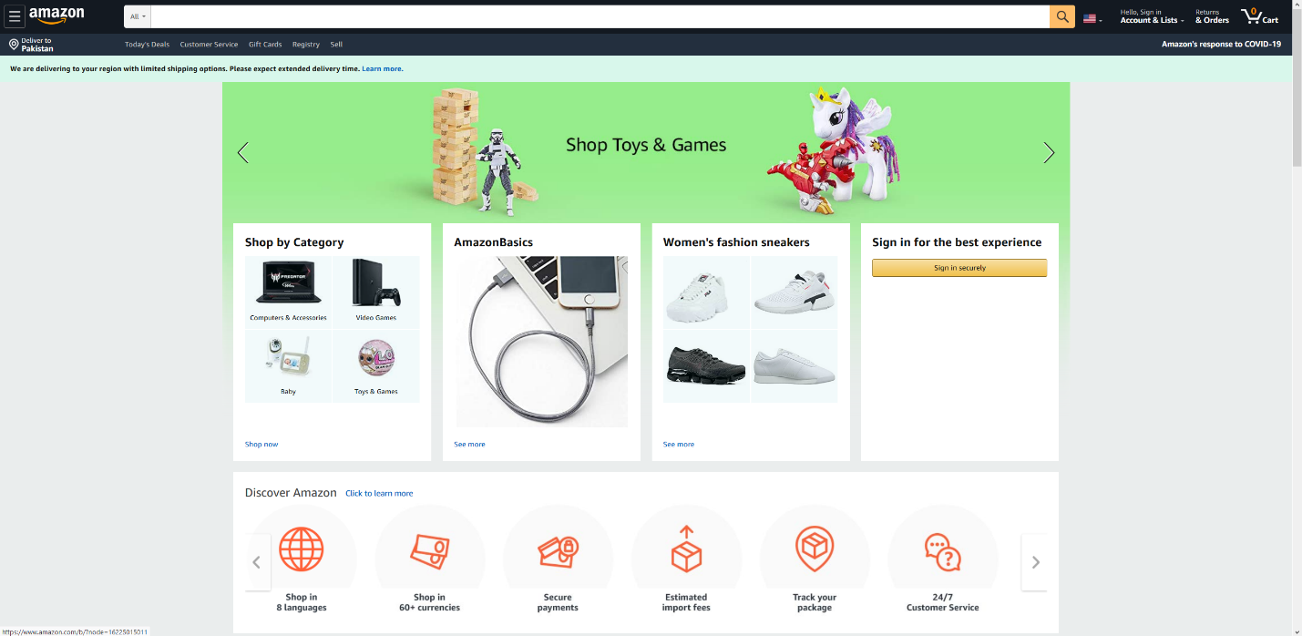

**Reasons:**

1. Good UI design
2. Responsive adjust it self according to other devices
3. Proper use of grid system
4. User friendly
5. Uses of high-quality images
6. Proper uses of font size/style
7. Great Loading system
8. Proper communication with server
9. Not boring
10. Proper working functionalities

**Example# 2**

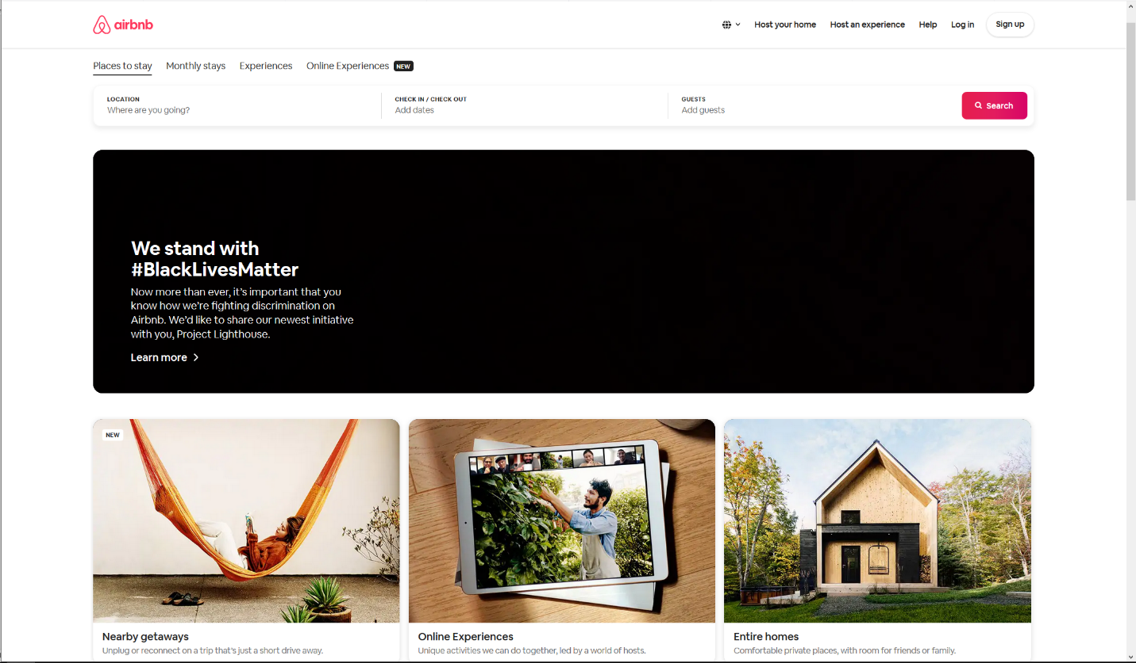

**Reasons:**

1. Fast loading time
2. UI adjust itself according to the devices
3. Good choice of colors
4. Proper user interaction with UI
5. Uses of good images
6. Listing page with proper description
7. Aside popup for live chat with client
8. Uses of proper typography
9. Organized content
10. Proper engagement with users

**Example# 3**

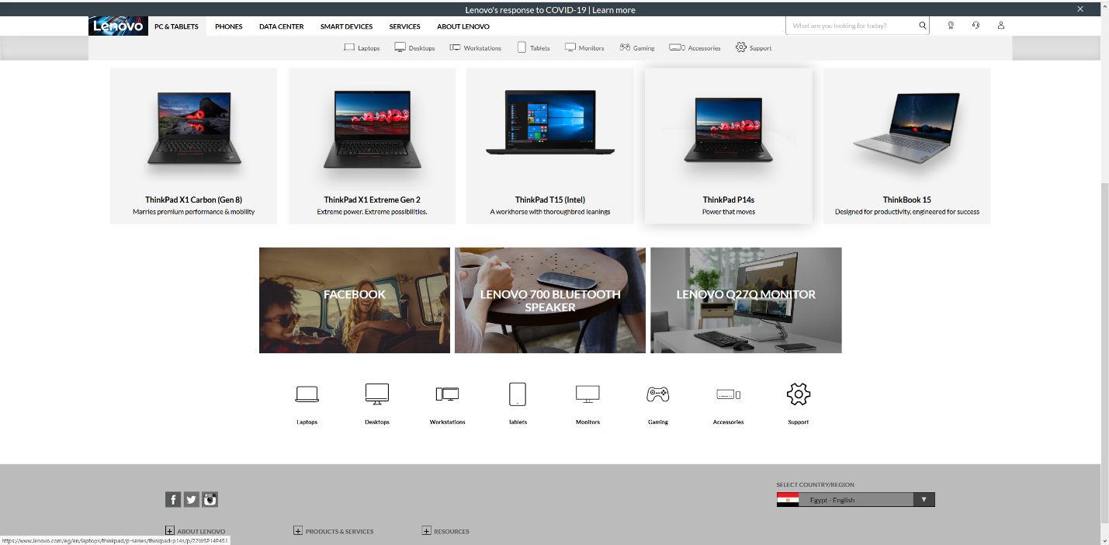

**Reasons:**

1. Proper loading of images
2. Proper uses of grid system
3. Responsive design
4. Fast search bar that will directly fetches & show result Realtime
5. Web content available on the all languages
6. Proper uses of font style/size
7. User friendly content
8. Proper working functionality
9. High quality images
10. Fast response from server